***Blue and Green are comments I left.***

***Everything else you can look at it see if can be worded better or need changes.***

***3-D Printed Jewelry & accessories ---***

**Business Idea**

Using the increase of use of Jewelry by people and those trying to get something that look nice at an affordable price. We can create a business that satisfy with those wants. The development of 3D printing has allowed of to created low cost and affordable product to the people. We not will only provide luxurious pieces but also affordable one that will make those who buy them be happy. One feature that will be available to customers is the request for custom designs. Customers can send their own design and have it custom made with materials that they want on it.

Somewhere around Pasadena… (This can be re-writing later)

**Competition**

**In this part we can leave what Stephanie had in the Powerpoint.**

**We can make a comment on how Pugster Inc would be a competition as they are basically doing what we are going to do. Although the are in which we would be situated is a bit different still they will have more history**

**Xue Feng also left a comment there for this—but I feel that it would go better in the speech part instead of filling out the PPT with words.**

**Role of IS**

The use of information system will allow us to collect data and applying it by understanding the demographic information of what people spend their hard earn income. How much they spend in apparel/ accessories (jewels/jewelry). Get information about the competition and how they perform around that area. Collect data of the expenses require to maintain the business. The need of the clients and what they would prefer to see in the store.

This need more work as this can only be for one slice, but we need bit more here. Probably the flow chart that Xue Feng did could work for the “define processes in the instructions but not sure”

**Revenue**

We will generate revenue through, up or down scaling the quality of the metals used in our jewelry. For example, if someone wants a ring since we 3-D print the Jewelry, depending on the customers’ need or want they can choose to have the rings band to be made from either silver, gold, or white gold on the spot. This allows us to reach a larger demographic of customers allowing us to generate high sales. Another way to generate revenue is if the customer wants to add either gems or diamonds to their jewelry they can then talk to our jewelers for a more personal and tailored experience when designing their jewelry, the way they want. By doing this it also allows us to reach the luxury market of jewelry to help generate revenue.

**Customers**

Our mission is to provide good and reliable jewels and jewelry to all ages. That on itself it the main goal but, in specifics ages around 12+ years old would be our focus. Reason behind this would be because in the case of young people, they then to go with the fashion and trend of the moment. So, for them we can provide accessories that follow the current trend for and affordable price. For young adults and older besides the affordable designs, higher quality would be at their reach as well as the ability to request custom design unique to for the individual. Also, our target customers would mainly be in the middle- and high-income class as they are more lightly to spend their extra income in appeals and goods.

**Location Analytics I**

Our Process for the GIS analysis was by looking with areas with high people traffic. As well with areas that are around people with high to medium disposable income. Also knowing where others Jewelry relates stores are located and find an area in which there is still high traffic of people while still keeping a good distance, so our business doesn’t overlap with the others.

The location of the store would be around Pasadena area near W Historic Rte 66 and E Colorado Blvd (The map only shows E Colorado Blvd as the main street, goggle maps shows both of them You can leave which ever you think is better), as those areas are highly active and there a lot of commercial places around. It will bring people to them and those interested in jewelry even out of curiosity would be attracted to come and inspect around. From those there my by few sales, or people that would be interested to buy later… (This can be worded different. Or set up different up to you.)

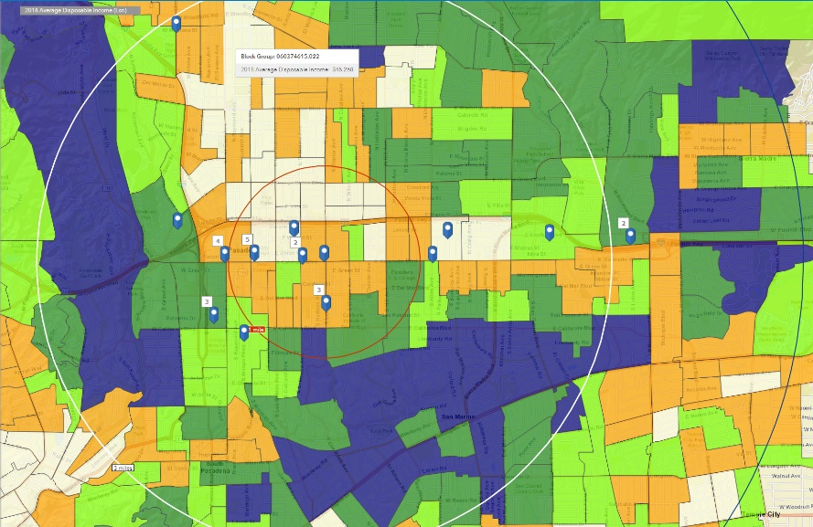**Location Analytics II**

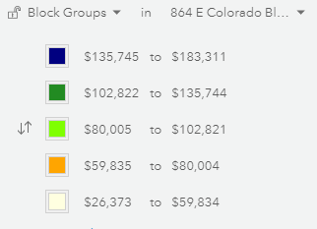

**Location Analytics II (This need bit more wording or we can just mention it during the presentation)**

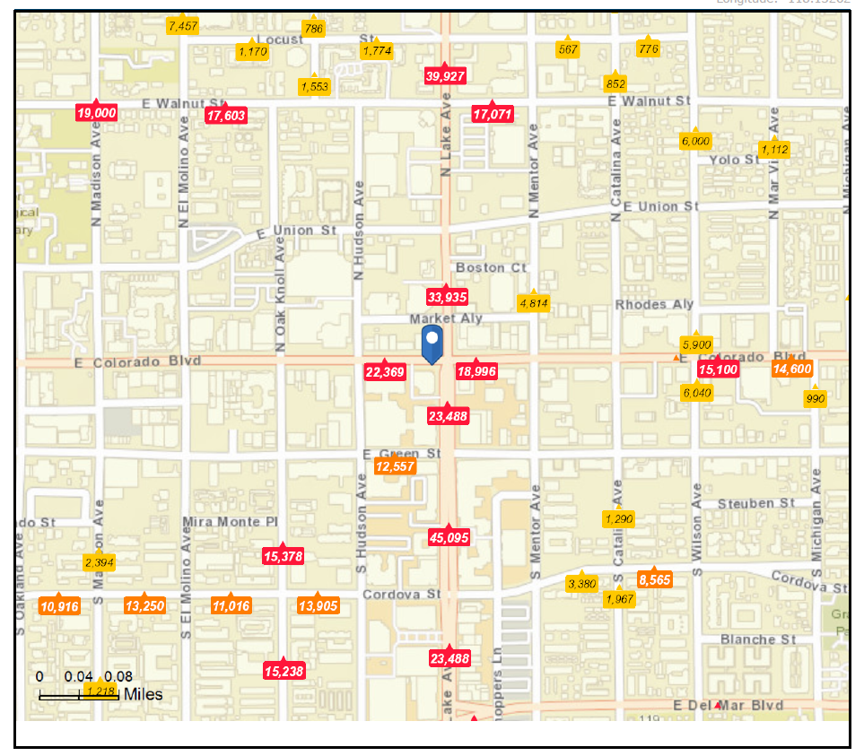Location of the store… Reason is because the high traffic of people around that area

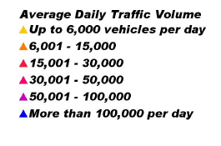

**Location Analytics III**

**(I am not quite sure what can we put there)**

**Location Analytics IV**

**II and III need to be summarize… Will try that later out today (00:23 as I’m typing)**

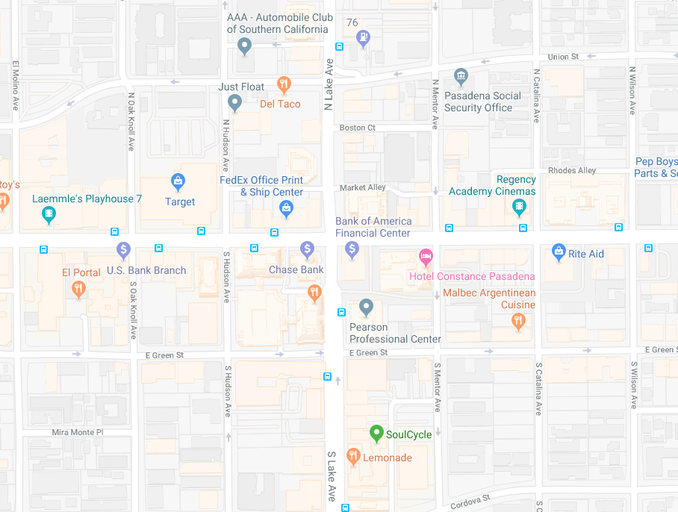**Location Analytics V**

Around - 864 E Colorado Blvd, Pasadena, California, 91101

**Location Analytics VI**

**Got the report but not know how I could summarize that. I send an email with the file see if someone can work around it.**

**Marketing Strategy**

The marketing strategy will be base on attendance (promotion with a booth). Show part of the jewelry collection and advertise their value.

Used of website which will allow to increase visibility in the market, collect information and process orders.

Another option will be as the first one promotion using networks, art/jewelry galleries. Create relations with galleries that would be willing to exhibit some of the Stores pieces, which will allow people to know about the store and attract more customers.

**Messaging Strategy**

**Yeah I don’t know what the message could be**

**Are you going to be profitable?**

According to analysts at the Retail Owners Institute, the gross margin percent trends for jewelry businesses have stayed relatively consistent in recent years. Gross profit margin is calculated by subtracting the cost of goods from a business's revenues. In 2013, the gross profit margin for jewelry stores was 43.5 percent. In 2017, it was 42.6 percent.

<https://smallbusiness.chron.com/percent-profit-margin-retailers-expect-jewelry-73996.html>

(Yeah I don’t know if to leave that… by looking up I could say it can be profitable… but that small paragraph sounded so good that I couldn’t think in anything better so I put that there. You can fix if or paraphrases if you want/ can)

**Conclusion**

This can be left to the end… once we have all the information.

**Three Wows**

**Same.**